**KENDRIYA VIDYALAYA No.1**

**Air Force - 1**

**Jamnagar**

**C++ Project Work**



Prepared By: - Submitted To:-

ARUN Kr. Singh Mr. K.K. Kumawat

Class - XII-D PGT (COMP.SCI.)

Session – 2013-14

ROLL NO.: 04

**CANTEEN**

**MANAGEMENT**

**CERTIFICATE**

**This is to certify that *Arun Kumar Singh,* the bonafide student of Class XII (Science) of Kendriya Vidyalaya No. 1, AFS Jamnagar have successfully completed the Computer Science project on *“Canteen Management”* in the academic year 2013-2014.**

**Internal Examiner External Examiner**

**Principal**

**Date:-…………………**

**I wish to express my deep gratitude and sincere thanks to Principal sir Mr. Shekhar Jakhoria, Kendriya Vidyalaya No. 1 AFS Jamnagar for his encouragement and for all the facilities that he provided for this project work. I sincerely appreciate this magnanimity by taking me into his hold for which I shall remain indebted to him.**

**I extend our hearty thanks to Mr. K.K. Kumawat, Computer Science teacher, who guided me to the successful completion of this project. I take this opportunity to express my deep sense of gratitude for his invaluable guidance, constant encouragement, constructive comments, sympathetic attitude and immense motivation, which has sustained my efforts at all stages of this project work.**

**I can’t forget to offer my sincere thanks to my classmates who helped me to carry out this project work successfully & for their valuable advice & support, which I received from them time to time. I would also like to express my gratitude to the school for letting me to use the school laboratory.**

**Name:-**

**ARUN KUMAR SINGH**

|  |  |  |
| --- | --- | --- |
| **S. NO.** | **TOPIC** | **PAGE NO.** |
| **1)** | **INTRODUCTION TO C++** | **6** |
| **2)** | **INTRODUCTION TO THE PROJECT** | **7** |
| **3)** | **FEATURES** | **8** |
| **4)** | **MINIMUM SYSTEM REQUIREMENTS** | **9** |
| **5)** | **SOURCE CODE** | **10 - 19** |
| **6)** | **OUTPUT** | **20 - 25** |
| **7)** | **BIBLIOGRAPHY** | **26** |

**The C++ programming language was developed at AT&T Bell laboratories in the early IGSO’s by Bjarne Stroustrup. He found out “C” lacking for simulating and decided to extend the language by adding features from his favorite language. Simta Sj was one of the object-oriented languages. Bjarne Stroustrup called it “C with classes” originally. The name C++ was coined by Rick Mascitti where “++” is the C increment operator. Ever since its birth, C++ evolved to cope with problems encountered by users, and through discussions at AT&T.**

**The major reasons for its success is the support for object oriented programming, which is most near to real world situations.**

**However, the maturation of the C++ language is attested by two recent events:-The formation of an ANSI (American National Standard Institute) C++ committee, and the publication of the Annotated C++ Reference Manual by Ellis and Stroustrup. One can easily judge the importance of C++ as given in the following lines:-**

***“*Object-oriented technology is regarded as the ultimate paradigm for the modeling of the information in the data of logic. The C++ is now shown to fulfill this goal.”**

**We are moving into an information age. More and more, day by day, we are getting influenced by technology. In fact today’s technology is shaping our work patterns. Today’s children are probably more comfortable and familiar with the today’s technology and guidance in the responsible use of the information that they will be able to get with more facility. Therefore, one more reasonable goal for the education would seem to be developed basic knowledge of the structures and operating principles behind the most common tools. That is why; educating boards keep giving projects so that to meet the changing needs. As a student, I felt the need to compile a programme so that the tallest specifications of ANSI C++ can be introduced within the scope of this software “one thing I want to emphasize here is that the new specifications that have been maintained in the programme, can be implemented practically only on newer compilers that conform to these latest ANSI C++ specifications “.**

**It is rightly said that “nothing is permanent but.” This programme is no exception to that; one needs to evolve oneself to keep pace with changing needs and requirements.**

**FEATURES**

* **The main Feature of the program is user friendly.**
* **Program is completely flexible and will not produce any garbage value or Output.**
* **Program uses functions calling so that one can roam throughout the program without any break.**
* **This program also uses array by which bulk of variables can handled easily.**
* **This Program uses data file handling concepts and also stores the data entered by the Users.**

**MINIMUM SYSTEM**

**REQUIREMENTS**

* English version of Microsoft[R] Windows 98/ ME/ 2000/ XP/ VISTA/ 7.
* Pentium[R] III 600 MHz or ATHLON[TM] 600 MHz or higher processor.
* At least 128 MB of RAM.
* 1 MB of uncompressed Hard Disk space.
* SVGA, HIGH-COLOUR [16-bit or 32-bit].
* Turbo C++.

/* &&&&&&&&&&&&&&&&&&&&&&&&&&&&&&&&

& COMPUTER SCIENCE PROJECT WORK&

&&&&&&&&&&&&&&&&&&&&&&&&&&&&&&&&

SOFTWARE FOR THE USE OF CANTEEN DEPARTMENT

////INTRODUCTION////

/////////////////////////////

//NAME:- ARUN KUMAR SINGH /

//CLASS:- XII /

// /

/

/////////////////////////////

####################

#CANTEEN MANAGEMENT#

#################### */

/*## HEADER FILES ##*/

#include<iostream.h>

#include<conio.h>

#include<string.h>

#include<stdio.h>

#include<process.h>

#include<iomanip.h>

#include<dos.h>

main()

{

clrscr();

unsigned int sum,add,d,i,j,e,f,g,h,k,l,w,x,y,z;

unsigned int bir=10,per=36,der=110,mur=8,par=110,cor=90,twr=1199, lur=17,tir=107,

rer=1499;

int qubis=1000,abis=0,qupep=1000,apep=0,quden=110,aden=0,qumun=1000,amun=0,quperk=500,aperk=0,qucoc=400,acoc=0,qutit=100,atit=0,qulux=1000,alux=0,qutid=1000,atid=0,quree=300,aree=0;

unsigned int m=0,n=0,o=0,p=0,q=0,r=0,s=0,t=0,u=0,v=0;

char name[50],rank[10],pu,c[20],a[15],b[15],ok;

clrscr();

printf("\n +++++++++++++++++++++++++++++++++++++++*++++++++++++++++++++++++++++++++++++++");

printf("\n + *** +");

printf("\n + ***** +");

printf("\n + ******* +");

printf("\n + ********* +");

printf("\n + *********** +");

printf("\n + ************* +");

printf("\n + *************** +");

printf("\n + ***************** +");

printf("\n + ******************* +");

printf("\n + ********************* +");

printf("\n + *********************** +");

printf("\n + ************************* +");

printf("\n + *************************** +");

printf("\n + ***************************** +");

printf("\n + ******************************* +");

printf("\n + ********************************* +");

printf("\n + *********************************** +");

printf("\n + ************************************* +");

printf("\n + *************************************** +");

printf("\n + ***************************************** +");

printf("\n + ******************************************* +");

printf("\n + ********************************************* +");

printf("\n + *********************************************** +");

printf("\n + ************************************************* +");

printf("\n + *********************WELCOME*********************** +");

printf("\n + **********************to*************************** +");

printf("\n + *****************canteen management****************************** +");

printf("\n + ********************by************************* +");

printf("\n + *******************Arun Kr. Singh ************************ +");

printf("\n + *************************************** +");

printf("\n + ************************************* +");

printf("\n + *********************************** +");

printf("\n + ********************************* +");

printf("\n + ******************************* +");

printf("\n + ***************************** +");

printf("\n + *************************** +");

printf("\n + ************************* +");

printf("\n + *********************** +");

printf("\n + ********************* +");

printf("\n + ******************* +");

printf("\n + ***************** +");

printf("\n + *************** +");

printf("\n + ************* +");

printf("\n + *********** +");

printf("\n + ********* +");

printf("\n + ******* +");

printf("\n + ***** +");

printf("\n + *** +");

printf("\n +++++++++++++++++++++++++++++++++++++++*++++++++++++++++++++++++++++++++++++++");

getch();

clrscr();

cout<<"\n\n\t w w e e e e e e e e l ";

cout<<"\n\n\t w w w e l ";

cout<<"\n\n\t w w w w e l ";

cout<<"\n\n\t w w w w e e e e e e e e l ";

cout<<"\n\n\t w w w w e e e e e e e e l ";

cout<<"\n\n\t w w w w e l ";

cout<<"\n\n\t w w w w e l ";

cout<<"\n\n\t w w e e e e e e e e l l l l l l l l";

cout<<"\n\n\n\n c c c c c c c o o o o o o o m m e e e e e e e e ";

cout<<"\n\n c o o m m m m e ";

cout<<"\n\n c o o m m m m e ";

cout<<"\n\n c o o m m m m e e e e e e e e ";

cout<<"\n\n c o o m m m m e e e e e e e e ";

cout<<"\n\n c o o m m m m e ";

cout<<"\n\n c o o m m m m e ";

cout<<"\n\n c c c c c c c o o o o o o o m m m e e e e e e e e ";

getch();

clrscr();

main:;

cout<<"\n\n\n\t\t\t AFFWA CANTEEN MANAGEMENT";

cout<<"\n\n\nCONSUMER INFORMATION";

cout<<"\n\n\n\n NAME:";

gets(name);

cout<<"\n RANK:";

gets(rank);

cout<<"\n SERVICE NO.:";

cin>>a;

cout<<"\n SMART CARD NO.:";

cin>>b;

cout<<"\n PHONE NO.:";

cin>>c;

cout<<"\n ENTER BILL NO.:";

cin>>i;

again:;

clrscr();

cout<<"\n\n\n\n\1.MENU & PURCHASE";

cout<<"\n\n\n\2.DETAILS";

cout<<"\n\n\n\3.NEW CUSTOMER";

cout<<"\n\n\n\4.QUANTITY AVAILABLE";

cout<<"\n\n\n\5.EXIT";

cout<<"\n\n\nENTER YOUR CHOICE:";

cin>>d;

clrscr();

switch(d)

{

case 1:

cout<<"\nITEMS\t\t\t\t\t\t\t RATE(RS)";

cout<<"\n\n\nBISCUTE\t\t\t\t\t\t\t\t10 ";

cout<<"\n\nPEPSODENT\t\t\t\t\t\t\t36";

cout<<"\n\nDENIM POWDER\t\t\t\t\t\t\t110 ";

cout<<"\n\nLUX SOAP\t\t\t\t\t\t\t17 ";

cout<<"\n\nTIDE\t\t\t\t\t\t\t\t107 ";

cout<<"\n\nREEBOK SHOES\t\t\t\t\t\t\t1499 ";

start:

cout<<"\n\n\nDO YOU WANT TO PURCHASE(Y/N):\n";

cin>>pu;

if(pu=='Y'||pu=='y')

{switch(pu)

case 1:

clrscr();

cout<<"\n\n\n\t\t\t\tPURCHASE LIST";

bis:;

cout<<"\nBISCUTE(MAX 30): ";

cin>>m;

if(m>30)

{

cout<<"Enter Quantity Smaller than 30";

getch();

goto bis;

}

else

abis=qubis-m;

pep:;

cout<<"\nPEPSODENT(MAX 2): ";

cin>>n;

if(n>2)

{

cout<<"Enter Quantity Smaller than 2";

getch();

goto pep;

}

else

apep=qupep-n;

den:;

cout<<"\nDENIM POWDER(MAX 2): ";

cin>>o;

if(o>2)

{

cout<<"Enter Quantity Smaller then 2";

getch();

goto den;

}

else

aden=quden-o;

mun:;

cout<<"\nMUNCH(MAX 50): ";

cin>>p;

if(p>50)

{

cout<<"Enter Quantity Smaller then 50";

getch();

goto mun;

}

else

amun=qumun-p;

park:;

cout<<"\nPARK AVENUE PERFUME(MAX 2): ";

cin>>q;

if(q>2)

{

cout<<"Enter Quantity Smaller then 2";

getch();

goto park;

}

else

aperk=quperk-q;

coco:;

cout<<"\nCOCONUT HAIR OIL(MAX 2): ";

cin>>r;

if(r>2)

{

cout<<"Enter Quantity Smaller then 2";

getch();

goto coco;

}

else

acoc=qucoc-r;

titan:;

cout<<"\nTITAN WATCH(MAX 2): ";

cin>>s;

if(s>2)

{

cout<<"Enter Quantity Smaller then 2";

getch();

goto titan;

}

else

atit=qutit-s;

lux:;

cout<<"\nLUX SOAP(MAX 10): ";

cin>>t;

if(t>10)

{

cout<<"Enter Quantity Smaller then 10";

getch();

goto lux;

}

else

alux=qulux-t;

tid:;

cout<<"\nTIDE(MAX 2): ";

cin>>u;

if(u>2)

{

cout<<"Enter Quantity Smaller then 2";

getch();

goto tid;

}

else

atid=qutid-u;

ree:;

cout<<"\nREEBOK SHOES(MAX 4): ";

cin>>v;

if(v>4)

{

cout<<"Enter Quantity Smaller then 4";

getch();

goto ree;

}

else

aree=quree-v;

cout<<"\n";

clrscr();

cout<<"\n\n\n\n\n\n\t\t\t\tAFFWA CANTEEN\n";

cout<<"\n\n\t\t\t\t CASH MEMO\n";

cout<<"\n\nBILL NO.:"<<i;

cout<<"\n\nNAME:";

cout<<name;

cout<<"\n\nRANK:"<<rank;

cout<<"\n\nSERVICE NO.:"<<a;

cout<<"\n\nSMART CARD NO.:"<<b;

cout<<"\n\nPHONE NO.:"<<c;

cout<<"\n\n\n\n\n";

cout<<"===============================================================================";

cout<<"\nITEMS" <<setw(40)<<"QUANTITY"<<setw(35)<<"PRICE(Rs.)";

cout<<"===============================================================================";

if(m>0)

cout<<"\n\nBISCUTE" <<setw(38)<<m<<setw(28)<<"Rs."<<m*bir;

if(n>0)

cout<<"\n\nPEPSODENT" <<setw(36)<<n<<setw(28)<<"Rs."<<n*per;

if(o>0)

cout<<"\n\nDENIM POWDER" <<setw(33)<<o<<setw(28)<<"Rs."<<o*der;

if(p>0)

cout<<"\n\nMUNCH" <<setw(40)<<p<<setw(28)<<"Rs."<<p*mur;

if(q>0)

cout<<"\n\nPARK AVENUE PERFUME"<<setw(26)<<q<<setw(28)<<"Rs."<<q*par;

if(r>0)

cout<<"\n\nCOCONUT HAIR OIL" <<setw(29)<<r<<setw(28)<<"Rs."<<r*cor;

if(s>0)

cout<<"\n\nTITAN WATCH" <<setw(34)<<s<<setw(28)<<"Rs."<<s*twr;

if(t>0)

cout<<"\n\nLUX SOAP" <<setw(37)<<t<<setw(28)<<"Rs."<<t*lur;

if(u>0)

cout<<"\n\nTIDE" <<setw(41)<<u<<setw(28)<<"Rs."<<u*tir;

if(v>0)

cout<<"\n\nREEBOK SHOES" <<setw(33)<<v<<setw(28)<<"Rs."<<v*rer;

e=m*bir;

f=n*per;

g=o*der;

h=p*mur;

k=q*par;

l=r*cor;

w=s*twr;

x=t*lur;

y=u*tir;

z=v*rer;

sum=e+f+g+h+k+l+w+x+y+z;

add=m+n+o+p+q+r+s+t+u+v;

cout<<"\n===============================================================================";

cout<<"\nTOTAL:"<<setw(40)<<add<<setw(27)<<"Rs."<<sum;

cout<<"\n\nTHANK YOU .\t\t\t VISIT US AGAIN\n";

getch();

clrscr();

goto again;

}

else

{goto again;

}

case 2:

cout<<"\n\n\n\n\n\t\t\t\tCANTEEN DETAILS";

cout<<"\n\n#TIMING:\n\n 11 AM TO 02 PM \n 03 PM TO 05 PM";

cout<<"\n\n#CANTEEN WILL CLOSED ON TUESDAY";

cout<<"\n\n#GOODS ONCE SOLD WILL NOT BE EXCHANGED/REPLACED";

cout<<"\n\n#TAKE YOUR SMART CARD WITH YOU";

cout<<"\n\n#COLLECT YOUR SMART CARD & BILL AFTER PAYMENT";

cout<<"\n\n#DO NOT BREAK ANY CANTEEN ITEMS";

getch();

clrscr();

goto again;

case 3:

goto main;

case 4:

if(m>0||n>0||o>0||p>0||q>0||r>0||s>0||t>0||u>0||v>0)

{cout<<"\n\t\t\tItems Avaliable in Canteen.\n\n\n";

cout<<"===============================================================================";

cout<<"\nITEMS" <<setw(40)<<"QUANTITY";

cout<<"\n===============================================================================";

cout<<"\n\n\nBISCUTE" <<setw(38)<<abis;

cout<<"\n\n\nPEPSODENT" <<setw(36)<<apep;

cout<<"\n\n\nDENIM POWDER" <<setw(33)<<aden;

cout<<"\n\n\nMUNCH" <<setw(40)<<amun;

cout<<"\n\n\nPARK AVENUE PERFUME"<<setw(26)<<aperk;

cout<<"\n\n\nCOCONUT HAIR OIL" <<setw(29)<<acoc;

cout<<"\n\n\nTITAN WATCH" <<setw(34)<<atit;

cout<<"\n\n\nLUX SOAP" <<setw(37)<<alux;

cout<<"\n\n\nTIDE" <<setw(41)<<atid;

cout<<"\n\n\nREEBOK SHOES" <<setw(33)<<aree;

cout<<"\n*******************************************************************************";

getch();

goto again;

}

else

{{cout<<"\n\t\t\tItems Avaliable in Canteen.\n\n\n";

cout<<"===============================================================================";

cout<<"\nITEMS" <<setw(40)<<"QUANTITY";

cout<<"\n===============================================================================";

cout<<"\n\n\nBISCUTE" <<setw(38)<<qubis;

cout<<"\n\n\nPEPSODENT" <<setw(36)<<qupep;

cout<<"\n\n\nDENIM POWDER" <<setw(33)<<quden;

cout<<"\n\n\nMUNCH" <<setw(40)<<qumun;

cout<<"\n\n\nPARK AVENUE PERFUME"<<setw(26)<<quperk;

cout<<"\n\n\nCOCONUT HAIR OIL" <<setw(29)<<qucoc;

cout<<"\n\n\nTITAN WATCH" <<setw(34)<<qutit;

cout<<"\n\n\nLUX SOAP" <<setw(37)<<qulux;

cout<<"\n\n\nTIDE" <<setw(41)<<qutid;

cout<<"\n\n\nREEBOK SHOES" <<setw(33)<<quree;

cout<<"\n\n*******************************************************************************";

getch();

goto again;

}

case 5:

cout<<"\n\n\n\n\n\n\n\n\n\t\t\t\t THANKS";

sleep(1);

clrscr();

cout<<"\n\n\n\n\n\n\n\n\n\n\n\n\n\n\t\t\t\t THANKS";

sleep(1);

clrscr();

cout<<"\n\n\n\n\n\n\n\n\n\n\n\n\n\n\n\n\n\n\n\n\t\t\t\t THANKS";

sleep(1);

clrscr();

cout<<"\n\n\n\n\n\n\n\n\n\n\n\n\n\n\n\n\n\n\n\n\n\n\n\n\t\t\t\t THANKS";

sleep(1);

clrscr();

cout<<"\n\n\n\n\n\n\n\n\n\n\n\n\n\n\n\n\n\n\n\n\n\n\n\n\n\n\n\n\t\t\t\t THANKS";

sleep(1);

clrscr();

cout<<"\n\n\n\n\n\n\n\n\n\n\n\n\n\n\n\n\n\n\n\n\n\n\n\n\n\n\n\n\n\n\n\n\t\t\t\t THANKS";

sleep(1);

clrscr();

cout<<"\n\n\n\n\n\n\n\n\n\n\n\n\n\n\n\n\n\n\n\n\n\n\n\n\n\n\n\n\n\n\n\n\n\n\n\n\t\t\t\t THANKS";

sleep(1);

clrscr();

cout<<"\n\n\n\n\n\n\n\n\n\n\n\n\n\n\n\n\n\n\n\n\n\n\n\n\n\n\n\n\n\n\n\n\n\n\n\n\n\n\n\n\n\n\t\t\t\t THANKS\n\n\n\t\t\t\tPress any key to Exit.......";

getch();

exit(0);

default:

cout<<"Your choice is wrong";

getch();

goto again;

}

//getch();

// return 0;

}

}

OUTPUT

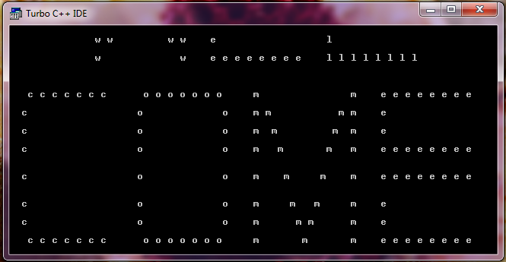

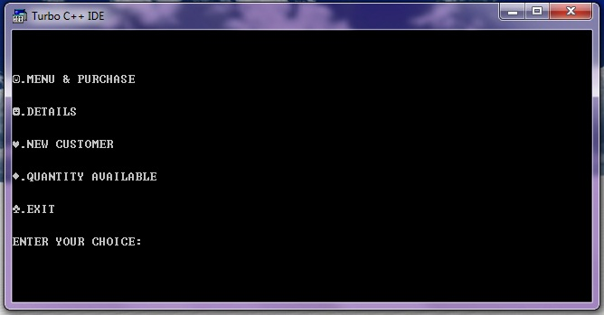

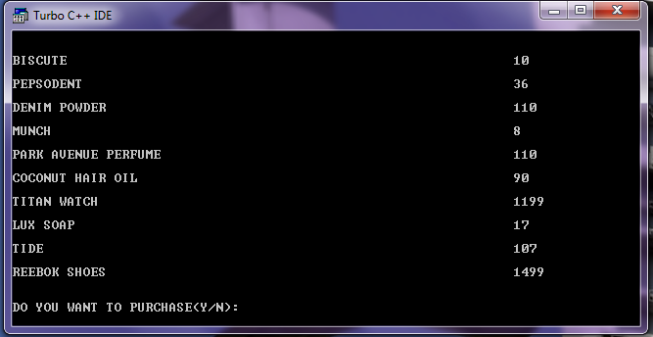

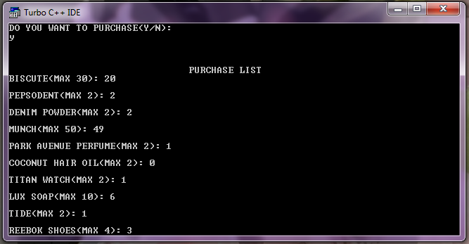

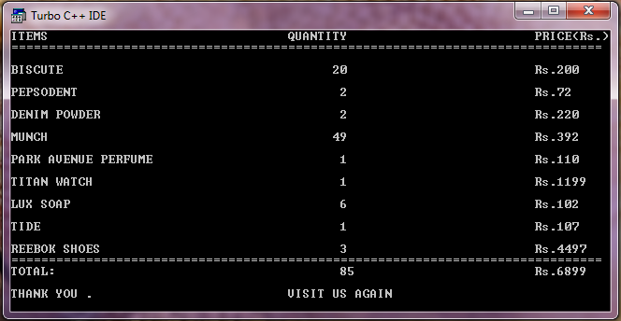

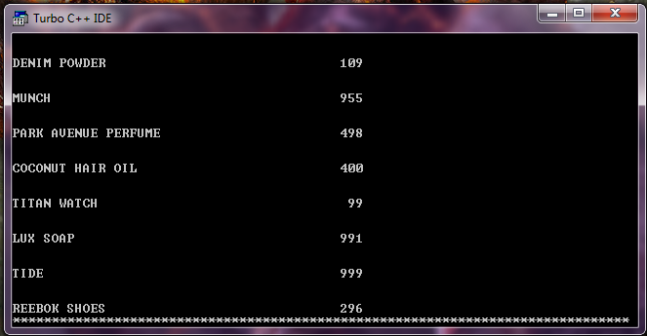

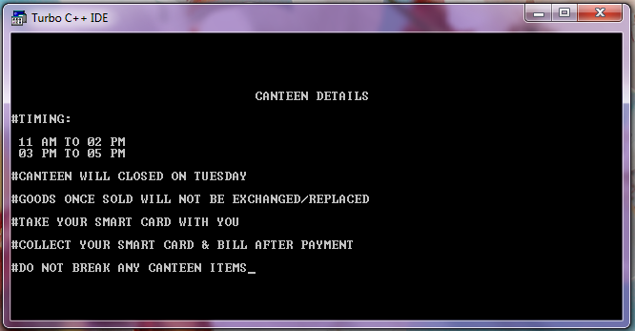

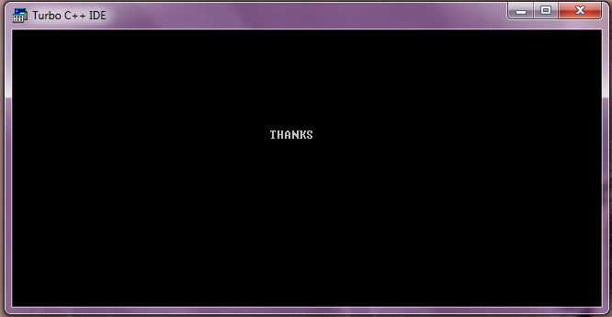

**The following things were referred to while preparing this project:-**

**COMPUTER SCIENCE WITH C++[Class XII] By Sumita Arora**

**COMPUTER SCIENCE WITH C++[Class XI] By Sumita Arora**

**LET US C++ By Yashwant kanetkar**

**A TEXT FOR COMPUTER SCIENCE [Class XI] By Satish jain**

**The following Links were referred to while preparing this Project:-**

* **www.cplusplus.com**
* **www.icbse.com**